1. Install nebula（Homebrew）

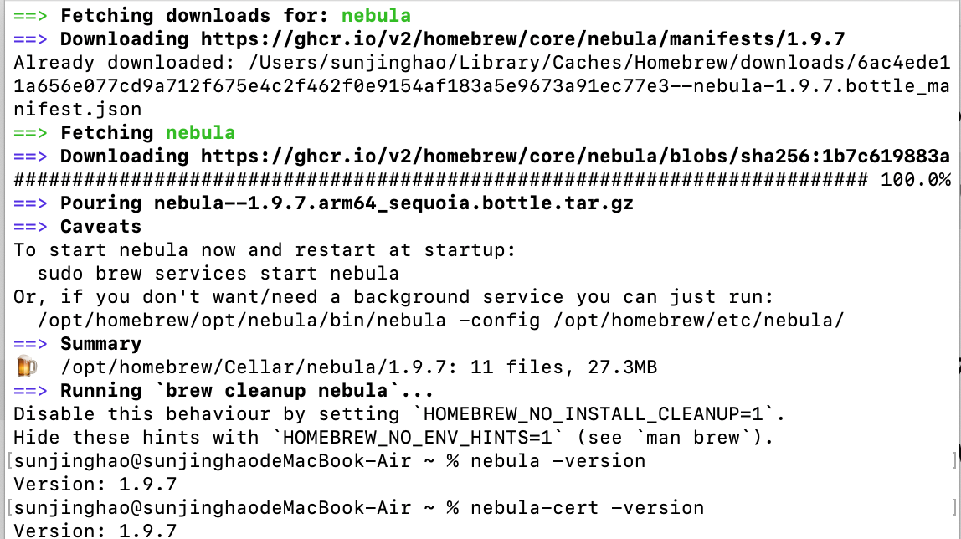

1. Create the directory and add the certificate

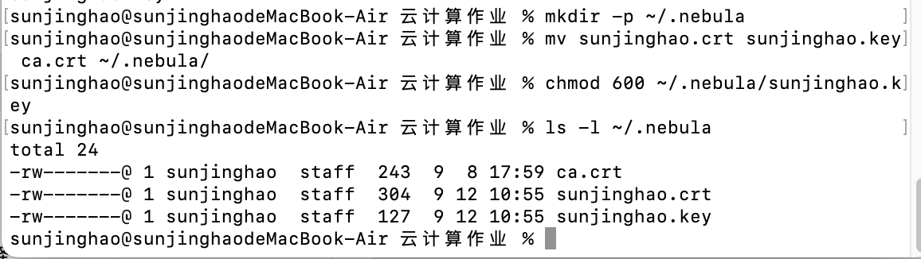

1. Create client’s config.yaml

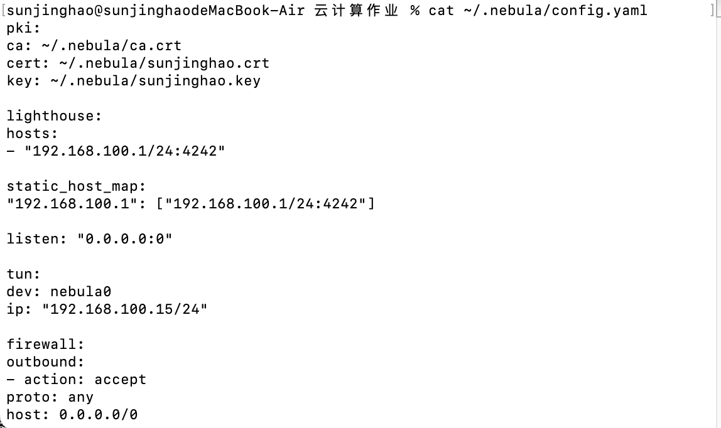

1. Start Nebula

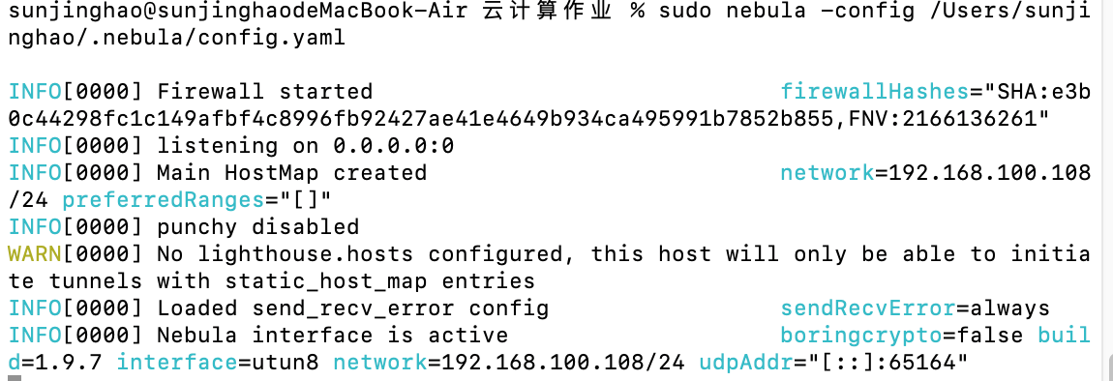

1. Verify the overlay network and connectivity

